Representative Council Meeting Date: May 19, 2021
Zoom – 3 pm
Officers  Dave Ryba, President (P)  Rafael Herrera, Vice President (P)  Stephanie Yee, Secretary (P)  Gerhard Peters, Treasurer (P) | Included on Executive Board  Jesus Gutierrez, At-Large Representative (P)  Senya Lubisich, At-Large Representative (P)  Paul Swatzel, At-Large Representative (P)  Other Leadership  Dave Brown, Bargaining Chair (P)  John Fincher, CCFA/Senate Liaison (P)  Terry Miles, Past President (P)
Representatives  Mathematics (P) Ralph Tippins  & Business (A) Esme Medrano  Health Sciences (A) Noemi Barajas  Career/Technical (P) Greg Lipp  Student Services (A) Vacant  (P) Elizabeth Cook  Visual & Performing (P) Matt Jackson  Arts | Representatives  Kinesiology (P) Steve Hartman  Language Arts (A) Elisabeth Garate  (P) Anna McGarry  Physical Sciences (A)  Social/Behavioral (P) Gailynn White  Sciences (A) Shelly Hahn  Negotiations Team (P) Stephanie Yee  Members (P) Rafael Herrera  (P) Senya Lubisich
Guests: Denise Kaisler, Sarah Bosler, Mariano Rubio, Nichole Ary, Jackie Boxley, Steve Gomez.

- Call to Order- Dave Ryba: Meeting called to order at 3:03 by Dave Ryba.

- Minutes: Jesus G. motion to approve and Steve H. seconded. Motion carries. Minutes from 3.17.21 and 4.21.21 approved (two sets of minutes).

- Officer and Cabinet Reports
  - President’s Report – Dave Ryba
- Engagement
Ryba says we have 99% dues paying members and yet we have struggled with engagement. This includes involvement such as at BOT meetings or support of a BOT candidate. Stephanie shared a draft of an engagement committee chair and samples roles and responsibilities

2. Fall Enrollment and Cameras in the Classroom
Ryba discusses Owl Cameras in classrooms, and this represents changes that could potentially be pushed on faculty in the Fall. Ryba asks the group if they have heard anything new about enrollment. Mariano expressed concerns that it has been challenging to get students enrolled in the Medium/Heavy Truck program. Terry expressed concern the College website is challenging and students can get frustrated. Gerhard brought up issues with fraudulent students and this effects enrollment. Anna said her dean said it is a problem across the State and is something the Chancellor’s Office is resolving. Ryba says most CCC districts have “more money than they know what to do with” but the question is what we do with it and what is the plan for the College. He asks the reps to keep a critical eye out for what is happening in their classroom and on campus or in their divisions. Ryba encourages people to come up with questions to be posed at the President’s candidate forum and to get a wide audience in attendance.

  - Vice-President’s Report – Rafael Herrera
Rafael presented the CTA Summer Institute event and walked everyone through example workshops. Jesus said you can even view them afterwards if you are unable to attend live.

  - Secretary’s Report – Stephanie Yee
Stephanie shared an example of a description for an Engagement Chair with duties.

  - Treasurer’s Report – Gerhard Peters
Gerhard walked the group though the certified results of Simply Voting for the election results and for the 2021-2023 Contract Ratification. Ryba asked the group if we should continue using Simply Voting. Gerhard feels they may not have participated because may not know the candidate or may not be making very thoughtful decisions but that is the tradeoff. We may have less voter turnout but more meaningful votes since they are more engaged. Paul advocates for the electronic voting since if people want to vote, they will vote. It is more hassle to walk around with paper ballots. Noemi says it is easier since all her colleagues have different hours, and it is challenging to coordinate paper ballots. Ryba feels it is a good idea to continue using Simply Voting.

Gerhard mentioned spending about $2000 on the end of the year including gifts for tenurees and retirees.
Gerhard went over the end of the year budget summary as follows:
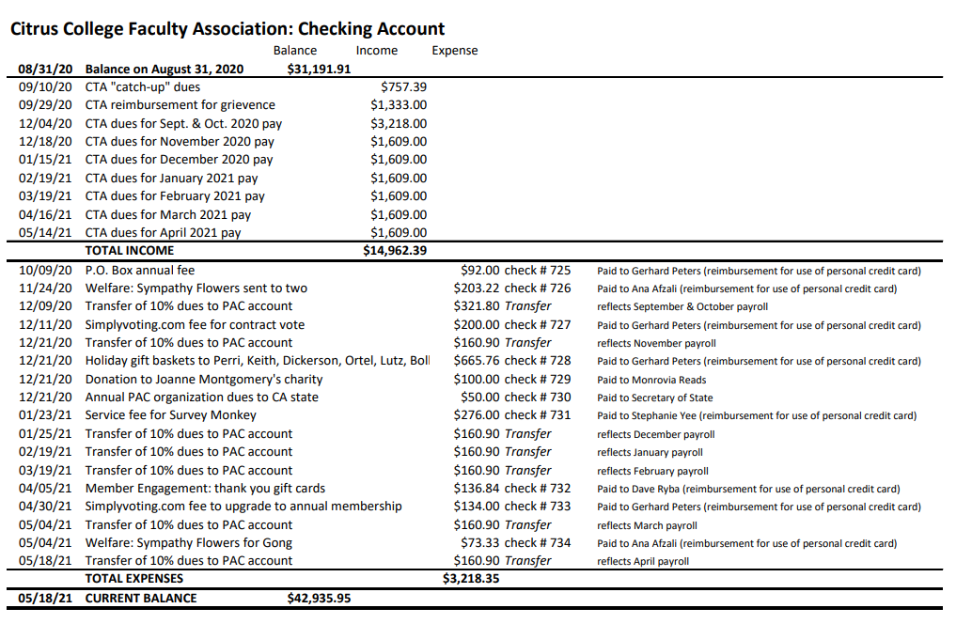
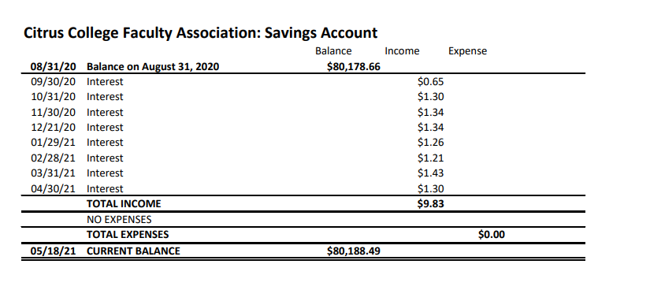

  - Bargaining Chair Report – Dave Brown
Brown says we will be discussing a summer and Fall MOU but that may be in flux depending on what the Governor decides to do as well as LA County. Paul brings up that some districts have brought up full vaccinations for all students but that may hurt or help us regarding enrollment depending on the local decisions from LA County. Brown says the 2% will be added to paychecks for the rest of the duration of the contract. He doesn’t have an answer when the retro checks will be distributed.

  - Past President’s Report – Terry Miles
Terry announced the end of the year event will be on Thursday, June 3 from 5-8. The plan is to either have a food truck or pizza and Gino Munoz can help us with light music.

  - Senate Liaison – John Fincher

- Standing Committee Reports
Faculty members shall be polled annually to determine their committee preference. The committee members should reflect the diversity of the CCFA membership.

1. Contract Committee – Dave Brown
See Bargaining Chair report

2. Grievance Committee – Rafael Herrera
No Report

3. Political Action Committee – John Fincher/Gerhard Peters
No Report

4. Benefits Committee– Terry Miles
No Report

5. Newsletter Committee - Stephanie Yee
No Report

6. Membership Engagement Committee- Vacant

7. Budget Committee-Dave Ryba
No Report

- Ad Hoc Committee Reports
Elections/voting – John Fincher

- Old Business
General Discussion:
- Officer Job Descriptions (tabled)

- New Business
- None

VIII. Public Forum
IX. Adjourn 4:22pm.

