Representative Council Meeting Date: February 17, 2021
Zoom – 3 pm
Officers  Dave Ryba, President (P)  Rafael Herrera, Vice President (P)  Stephanie Yee, Secretary (P)  Gerhard Peters, Treasurer (P) | Included on Executive Board  Jesus Gutierrez, At-Large Representative  Senya Lubisich, At-Large Representative  Paul Swatzel, At-Large Representative  Other Leadership  Dave Brown, Bargaining Chair  John Fincher, CCFA/Senate Liaison  Terry Miles, Past President
Representatives  Mathematics (P) Ralph Tippins  & Business (A) Esme Medrano  Health Sciences (P) Noemi Barajas  Career/Technical (P) Greg Lipp  Student Services (P) Raquel Gutierrez  (P) Elizabeth Cook  Visual & Performing (P) Matt Jackson  Arts | Representatives  Kinesiology (P) Steve Hartman  Language Arts (P) Elisabeth Garate  (P) Anna McGarry  Physical Sciences (A) Badieh Farahani  Social/Behavioral (P) Gailynn White  Sciences (A) Shelly Hahn  Negotiations Team (P) Stephanie Yee  Members (P) Rafael Herrera  (P) Senya Lubisich
Denise Kaisler

- Call to Order- Dave Ryba: Meeting called to order at 3:02 by Dave Ryba.

- Minutes: Dave Ryba asked for a motion to approve the minutes from October 21 and December 2 Cook motion to approve both sets of minutes and seconded by Hartman. Jesus does not feel comfortable with approval for the October minutes since he did not read them. No discussion. Minutes approved by consensus. Jesus abstained. Both sets of minutes approved.

- Officer Reports
  - President’s Report – Dave Ryba
    - CCA Conference
There was a CCA conference a couple of weeks ago. The budget for the state is not as dire as it once was, but reality is Citrus is down about 10%. DR focused on the budget talks, and says the picture is getting clearer. Specifically, the state’s budget is much less dire than had been predicted 2-3 months ago. However, there continues to be a serious lull in enrollment, as well as uncertainty as to what will be needed to come back to campus. Much as he disagrees with some of their (District) timidness and “cheapness”, he recognizes that they are faced with considerable uncertainty and have a responsibility to be cautious.

2. Contract Update
Ryba says that as president, and we, as eboard or rep council, have two top tier priorities. They’re a chicken/egg situation; we have to get the best possible contract for our unit, and we have to enforce that contract. Neither is worth a hoot if both aren’t done. Anyone who has watched Ryba will know that he is something of a broken record. Whether it’s pickiness with salary schedules, agitating about class assignments and cancellations, etc., he feels he is doing his required job. Others sometimes think he is just being obnoxious…but if we don’t enforce the contract, we effectively lose it. It’s not personal, it’s a job.

3. Class Cancellations
Class cancellations… “Mutual agreement” is still a problem. We are seeing things going on with class cancellations and the District is largely trying to accommodate and looking for solutions. We are in a paradigm of “they had to cancel me class, now what do I do”. We need to educate about what “had to” means” and how ”Assignments are offered to FT faculty first.” This is not consistently happening and impossible for the president to watch; reps need to. And the beauty is that once the deans are trained, this becomes a non-issue. In Chemistry, two new sections of 103 were created. To Ryba’s knowledge neither were offered to full timers. End result a non-issue, but process must be enforced. Dean agreed to toe the line going forward.

Ryba emphasizes that as rep council we have two functions and we have to enforce as well as ensure we have a good contract. Ryba again encourages we need to educate the difference between I have to cancel this class vs. I want to cancel this class. He encourages people to be creative and feel right about it, but it is not good to pre-agree that you will cancel the class if the enrollment is not met by taking a late start class for example.

4. By-Laws/Standing Rules
Ryba holding off on bylaws, but will buckle down this weekend and send out proposed detailed descriptions consistent with what was briefly discussed in September/October.

5. Officer Elections
Ryba says it seems that as soon as one election ends, another starts. He believes our history is to run elections fairly late in the semester, knowing the result in May. But time flies, and obviously faculty need to plan schedules, etc., He asked Gerhard to oversee this spring’s elections. He believes the offices to be elected are VP and Secretary, Area Reps, and departments reps.
6. BOT
Ryba says we all have a picture of how the district operates. For some of us that is limited to our own department, others have a more statewide view. In a simple view, our BOT is responsible for all decisions. They need to stay within the confines of the law. The information for the BOT has largely been from the CEO from the CFO. See diagram
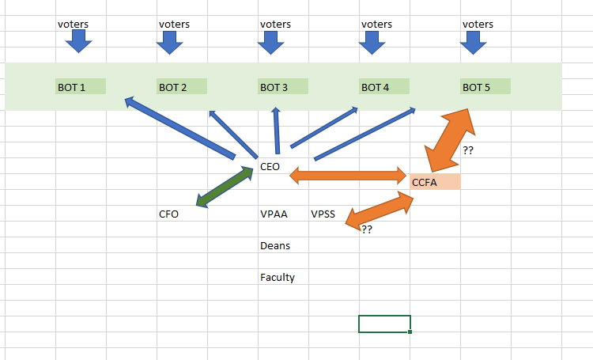

Jesus asks if we should serve on more committees to have a presence with new VPAA and VPSS. Ryba encourages people to enforce the language of the contract.

  - Vice-President’s Report – Rafael Herrera
Rafael updates that Claudia Castillo will be the new rep in Student Services. He also asks if there is a rep in Natural and Physical Sciences. He also announces a calendar of events will be created and perhaps put on Facebook group. Ryba recommends it be a on an outlook or google calendar.

  - Bargaining Chief Report – Dave Brown
See Old Business below.

  - Secretary’s Report – Stephanie Yee
Stephanie shares the updates to the www.citrusfac.org website and gives tour of additions and highlights the new sections.

  - Treasurer’s Report – Gerhard Peters
Checking account beginning balance under $32,000 and we are now at $37,000 and received the dues through the December pay period. Gerhard shares the February treasury report in the chat for review. He also reviewed the PAC fund and ending balance is $121k.

  - Past President’s Report – Terry Miles

  - Senate Liaison – John Fincher

- Standing Committee Reports
Faculty members shall be polled annually to determine their committee preference. The committee members should reflect the diversity of the CCFA membership.

1. Contract Committee – Dave Brown
See Bargaining Chair report

2. Grievance Committee – Rafael Herrera
No Report

3. Political Action Committee – John Fincher/Gerhard Peters
No Report

4. Benefits Committee– Terry Miles
No Report

5. Newsletter Committee - Stephanie Yee
No Report

6. Membership Engagement Committee- Jesus Gutierrez and Justina Rivadeneyra

7. Budget Committee-Dave Ryba
No Report

- Ad Hoc Committee Reports
Elections/voting – John Fincher

- Old Business

General Discussion:
- The Contract (Update)
Brown updates the team had a meeting with the District to discuss the spring 2021 MOU and to continue doing our services remotely. We will likely not return summer or fall and are looking at a phased in approach to classes and services on campus. All evaluations scheduled is proposed to be done earlier now.
- The District had shared an idea is to give stipends to faculty to doing transition work given the pandemic and now the District
- We have a signed agreement from March 2020 we are pushing evaluations back one year and now the District has proposed a modification to that agreement. At this time, CCFA is not inclined to agree to that.
- We have not had a formal meeting since the last, best, and final offer from November regarding contract negotiations because we wanted to survey our members first and we are still waiting for requested financial information such as latest CCSF311 and a detailed accounting of what has been done with CARES money.
- District wants to resolve the contract, and interested in coming back to table, but are waiting for certain pieces of information first.
- The District is not interested in stipending the faculty at this time for transition work.

- New Business
- None

VIII. Public Forum

IX. Adjourn
Meeting adjourned at 4:00 pm to transition to CTA Engagement Training hosted by Arleigh and Robin.

